These adjectives all collocate with which noun?
?
middle
maiden
pet

first
Christian
family
Work with a partner and discuss the meanings of the collocations, then check with your teacher.

Definitions

- Christian name- the same as a first name

- Family name – a name shared by members of a family (also surname, last name)

- First name – a name given to a person at birth

- Full name – your whole name, including your first, middle and family name.

- Maiden name – the original family name of a married woman who now uses her husband’s family name instead.

- Middle name – a second name that some people have between their first name and their family name.

- Pet name – an informal friendly name for a member of your family (or lover). This is slightly different in meaning to a nickname.

IELTS Academic Speaking Part 1

Topic: Names

Exercise 1

Rearrange the words to make questions. The capital letters and punctuation should help you.

- your / How / did / parents / choose / name? / your

- name / meaning? / your / have / any / special / Does

- name / unusual / your / or / country? / Is / your / in / common

- name, / you? / change / could / If / would / your / you

Exercise 2

Match questions 1-4 to answers A-D below.

- Yes it does. I think it means “to carry Christ in your heart”. It’s also the name of the patron saint of travellers – Saint Christopher. My mum gave me a Saint Christopher necklace for good luck when I travelled to Thailand for the first time.

- I definitely wouldn’t want to change my name – I like it. And also, if I changed it, I know my Mum would hit the roof! She’s a very emotional woman!
- I’m not sure who gave me my name… I think it was probably my Mum’s choice because she’s the only one who calls me “Christopher”. Everybody else calls me either “Chris” or “Cottee”. Cottee’s my nickname. I know my older brother James was named after my great- grandfather who was Scottish.

- I think Chris is a pretty common name. I’ve got quite a few friends called Chris. I don’t think it’s an unusual name at all.

Exercise 3

Ask and answer questions 1-4 with a partner. Remember to use informal language and give extended answers.

1. What’s even more incredible was that they went on to win The European Cup at their first attempt the following year.
2. This film was really interesting because it shows how football has changed so much over the last thirty or so years and it also reveals how Brian Clough used unorthodox methods to get his players to perform so well for him.
3. I’d like to tell you about a really fascinating documentary I watched recently called “I believe in miracles.”
4. Basically, he totally transformed the club from a mediocre second division team into a really exciting one which won promotion straight away and became champions of England the next season.
5. It’s a great film for anyone who likes football, no matter which club you support.
6. It tells the story of Nottingham Forest football club in the early nineteen eighties when they appointed a very outspoken but extremely charismatic manager called Brian Clough.
7. I heard about the film from a friend, and when I watched it I was totally absorbed in it because I can vividly remember them winning the European Cup when I was about 10 years old.
8. They show clips of the matches and interview the players about their memories - some of their anecdotes are really funny.

I’d like to tell you about a really fascinating documentary I watched recently called “I believe in miracles.”
It tells the story of Nottingham Forest football club in the early nineteen eighties when they appointed a very outspoken but extremely charismatic manager called Brian Clough. Basically, he totally transformed the club from a mediocre second division team into a really exciting one which won promotion straight away and became champions of England the next season. What’s even more incredible was that they went on to win The European Cup at their first attempt the following year.

I heard about the film from a friend, and when I watched it I was totally absorbed in it because I can vividly remember them winning the European Cup when I was about 10 years old. They show clips of the matches and interview the players about their memories - some of their anecdotes are really funny.

This film was really interesting because it shows how football has changed so much over the last thirty or so years and it also reveals how Brian Clough used unorthodox methods to get his players to perform so well for him.

It’s a great film for anyone who likes football, no matter which club you support.

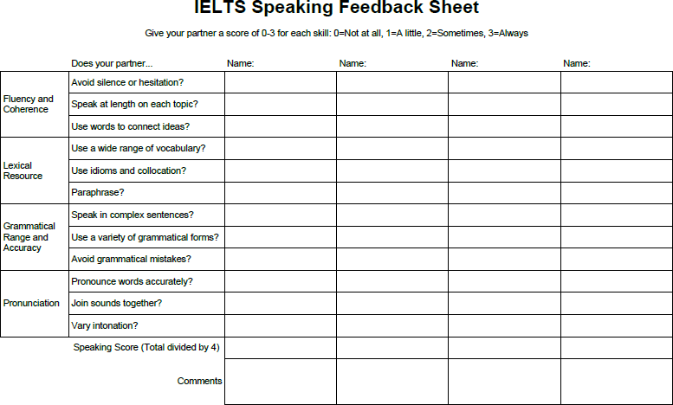

Resource 4

Read the statements below and decide if they are good or bad ideas for Part 2 of the IELTS speaking test. Give reasons for your answers.
- Read the topic card carefully.

- Ask the examiner for help if you don’t understand a word on the topic card.

- Write full sentences in the minute you are given to prepare.

- Do not make any notes before you speak.

- Use the prompts on the topic card to help you organize your talk.

- Draw a mind map or make a list.

- Write down key vocabulary (about 10 -15 words) to use in your talk.

- Read from the topic card when you give your talk.

- Paraphrase the language on the topic card to introduce your talk.

- Start your talk with a clear and confident introduction.

- Finish your talk in less than a minute.

- Say “finished!” when you’ve finished your talk.

Test 4

SPEAKING

PART 1
The examiner asks the candidate about him/herself, his/her home, work or studies and other familiar topics.

EXAMPLE
Names
- How did your parents choose your name(s)?
- Does your name have any special meaning?
- Is your name common or unusual in your country?
- If you could change your name, would you? [Why/Why not?]

PART 2

You will have to talk about the topic for one to two minutes. You have one minute to think about what you are going to say. You can make some notes to help you if you wish.
Describe a TV documentary you watched that was particularly interesting.

You should say:
what the documentary was about why you decided to watch it
what you learnt during the documentary and explain why the TV documentary was particularly interesting.

PART 3
Discussion topics:

Different types of TV programmes
Example questions:
What are the most popular kinds of TV programmes in your country? Why is this? Do you think there are too many game shows on TV nowadays? Why?
Do you think TV is the main way for people to get the news in your country? What other ways are there?

TV advertising
Example questions:
What types of products are advertised most often on TV?
Do you think that people pay attention to adverts on TV? Why do you think that is?
How important are regulations on TV advertising?

